# Introduction to the Labour Force Survey and Annual Population Survey Workshop

# **Navigating and using LFS documentation**

The LFS has extensive documentation to help you understand and use the data. This exercise is designed to show you how to navigate and use the LFS documentation**.**

#### Task: Using the documentation, explore variables that can be used to answer a research question

*Scenario:* You are interested in zero-hour contracts (casual contracts in which the employer does not guarantee the individual any hours of work each week). You want to carry out some exploratory analysis to find out who is reliant in zero-hour contracts. In particular, you are interested in exploring if migrants are more likely to have zero-hour contracts and if there are geographical differences.

#### Learning outcomes

* Know what is in the different volumes of the user guide
* Know how to use the documentation to find out information about variables and different datasets such as which questions are asked when and change in variables over time.
* Can identify and understand multi response and derived variables

## Part 1 – Exploring documentation

### 1. UKDS Catalogue page

This activity will start by looking at data available from the October-December 2020 Quarterly Labour Force Survey (SN 8777).

[Start by navigating to the catalogue page for the dataset](https://beta.ukdataservice.ac.uk/datacatalogue/studies/study?id=8777).

### 2. LFS User Guide Vol 2. – Questionnaire

On the catalogue page, navigate to the documentation tab.

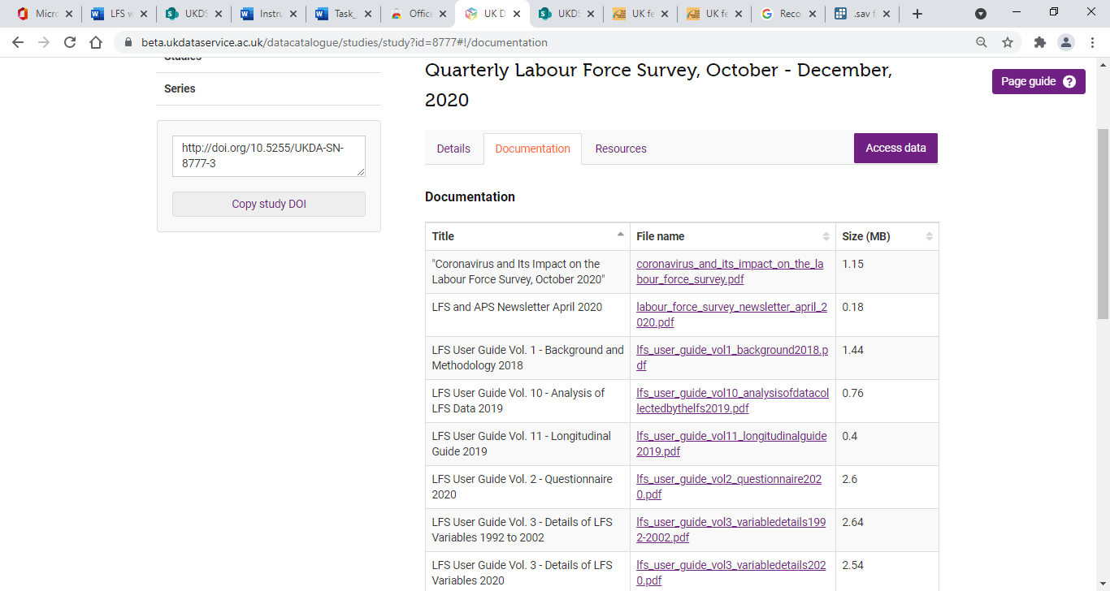

Find and open ‘LFS User Guide Vol 2. – Questionnaire’. Locate any questions that collect information about zero-hour contracts. Hint: use the find function (CTRL+F) to search for ‘zero’.

Question 1: What is the name of the variable assigned to the question that asks about zero-hour contracts?

Note that the question is a **multi-response variable** – up to three responses can be selected. It will be important to know how multiple-response variables are handled in the dataset.

### 3. LFS User Guide Vol. 3 – Details of LFS Variables 2020

Find out more information about variables capturing zero-hour contracts by looking at ‘LFS User Guide Vol. 3 – Details of LFS Variables 2020’. Again, start by searching the document for ‘zero’.

You should discover that there are more variables in Vol. 3 that include information about zero-hour contracts. This is because Vol. 3 includes information about the derived variables.

Look at the details for FLEX10 on p.163. Here we can find out additional information including:

* The question is asked in all quarters and waves, but this is a recent change (since 2020)
* You can find out details about multiple response variables at the beginning of the user guide (see page 3).

**Question 2:** What does the (1-3) in the name FLEX10(1-3) refer to?

Question 3: What is the name of the derived variable that is labelled: Whether respondent works zero hours contract?

### 4. LFS User Guide Vol. 4 – Standard Derived Variables 2016

How has FLEXW7 been derived?  You can learn more about derived variables by examining ‘Vol. 4 – Standard Derived Variables 2016’. Search for FLEXW7 and you will find the details on p.140.

**Question 4:** How does FLEXW7 vary from FLED10?

### 5. Data Dictionary

Next, you can search the data dictionary for the derived variable for zero-hour contract workers. The data dictionary will tell you information about each variable in the named dataset, including: position number, name, label, measurement level, and categories. Below is an excerpt from the data dictionary for the October-December 2020 QLFS.

Image showing details of entry in the data dictionary:
Pos. = 171
Variable = FLEXW7
Variable label = Respondent has zero hours contract
Value = 1.0 Label = Yes
Value = 2.0 Label = No
Value = -9.0 Label = Does not apply
Value = -8.0 Label = No answer

## Part 2 – Explore options for analysis

### Zero-hour contracts among migrants to the UK

Use the same documentation to find out if you can explore zero-hour contracts among migrants to the UK.

*Are there variables to identify immigrants to the UK? Can you identify by country of birth or origin? (Potential search terms: ‘birth’ or ‘country’.) What is included in the dataset?*

**Question 5.** What variables can you find to identify migrants in the analysis?

### Geographical differences in zero-hour contracts

Is it possible to examine geographical differences in relation to zero-hours contracts?

*What variables can you find relating to geography? Which versions of the data are they included in?*

**Question 6.** What variables can you find for geography?

**Movement in and out of zero-hours contract**

**Question 7.** Can you carry out analysis to see if individuals move in and out of zero-hour contracts over time? What steps would you take to find out?